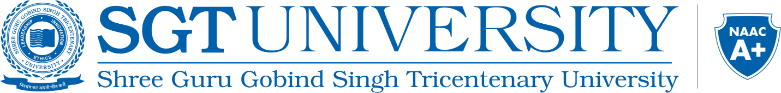

**I**nternational **S**ummit on **H**olistic Innovations for **N**ations’ **E**mpowerment **(I-SHINE-2025 AI)**

***Theme: Harnessing Artificial Intelligence for Sustainable Growth: Envisioning a Viksit Bharat by 2047***

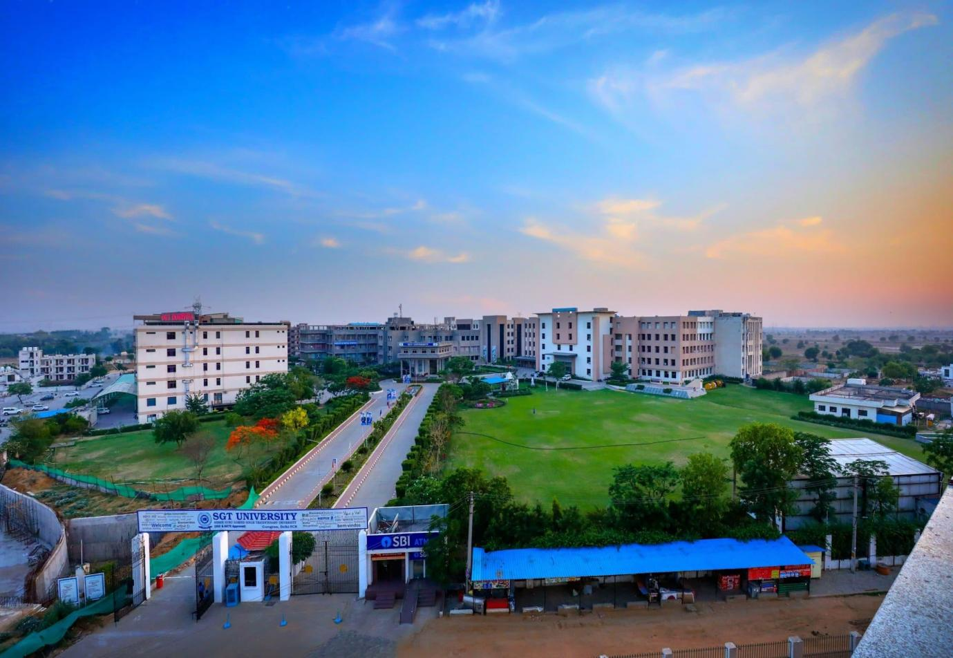

**9th- 10thMay, 2025**

**Conference Venue: C Block, Auditorium**

**Conference Mode: Hybrid Mode**

**Organized by**

**Central Academic Clubs,**

**(SGT University)**

**Venue**

SGT University, Gurgaon-Badli Road Chandu, Budhera, Gurugram, Haryana 122505

**About the SGT University**

SGT University is a UGC-recognized institution, established in 2013, that has broad ambitions to promote research, innovation, and multidisciplinary education. Our sizable campus, which is located on the outskirts of Gurgaon, spans more than 70 acres and has every type of resource and infrastructure available to facilitate optimum academic and research output. Our constant push for excellence led to us becoming one of the youngest universities to have received a NAAC A+ accreditation rating. Amongst our expansive range of specialties are our medical programs, taught in sync with SGT Medical College, Hospital & Research Institute, and considered to be some of the best in the country. SGT University offers courses across 18 faculties, including a variety of Undergraduate, postgraduate and PhD programs.

SGT University scaled horizontally by establishing Centre’s of Excellence like NRSC (National Reference Simulation Centre), CCSP (Centre for Cosmology Science & Popularization), CEAPS (Centre of Excellence for Andragogical and Pedagogical Sciences), and institutionalized CRC (Corporate Resource Centre), EDC (Entrepreneurship Development Centre), ACIC (Atal Community Innovation Centre), IIC (Institution's Innovation Council) - SGTU for focused attention and holistic development of students, faculty members, and Nation. Additionally, it has won a number of honors for its contributions to higher education, including the “Diamond Rating” from QSI- GAUGE and a “Diamond Band”from R world Institutional Ranking in the “Mental Health & Wellbeing” Category.

**About the Central Academic Clubs, SGT University**

Academics are an integral part of a student's life with an everyday learning experience, whether a graduate, post-graduate, or researcher. Shree Guru Gobind Singh Tricentenary University (SGTU) embarked on to promote academic activities at the campus through Academic Clubs. **The Central Academic Clubs** bring like minded students and teachers together with a common academic area of interest or academic objective, and provide such learning opportunities to students that they can’t acquire in the classroom. These student-driven platforms empower students to organize and participate in diverse academic activities, such as workshops and hands-on sessions. By extending learning beyond the regular curriculum, these clubs aim to enhance professional skills and foster holistic development outside the classroom.

Academic Clubs support innovative ideas of the students by providing them a platform to explore and experiment in any interdisciplinary model – aligned with the National Educational Policy (NEP) 2020. SGTU established Academic Clubs within various faculties and departments starting from the 2019-20 academic session to promote academic engagement.There are "eighty" Academic Clubs, driven by the students, followed by a structured methodology, under the guidance of Advisor(s) and Co-advisor(s), with shared decisions and responsibility.

**Anvaya** is the dynamic student body of academic clubs at SGT University. Word **Anvaya** is a Sanskrit word that translates to Accordance**.** Anvaya, as a student academic body, signifies **unity, harmony, and adherence to principles.** It was formed on 7 May 2024, entrusted with the exhilarating role of unifying and guiding academic clubs across all 18 faculties. Its mission is to ignite intellectual curiosity and drive innovation, fostering a thriving and collaborative academic ecosystem that inspires students to reach new heights.

**About the International Summit on Holistic Innovations for Nations’ Empowerment (I-SHINE 2025 – AI)**

The **International Summit on Holistic Innovations for Nations’ Empowerment (I-SHINE 2025 – AI)** is a pioneering global conference that brings together **leading researchers, academicians, policymakers, and industry experts** to explore the transformative potential of **Artificial Intelligence (AI) in fostering sustainable and inclusive growth**. This summit serves as a platform for **knowledge exchange, interdisciplinary collaboration, and innovation**, aiming to envision a **Viksit Bharat by 2047** through AI-driven advancements.

**Conference Theme:**

**"Harnessing Artificial Intelligence for Sustainable Growth: Envisioning a Viksit Bharat by 2047"**

As AI continues to **reshape industries, revolutionize governance, and enhance quality of life**, this conference will facilitate discussions on the **ethical, social, and technological dimensions of AI** in achieving national and global sustainability goals.

**Conference Objectives:**

* **Foster Interdisciplinary Collaboration** – Bringing together experts from **academia, industry, and government** to discuss AI-driven innovations.
* **Address Global and National Challenges** – Exploring AI applications in **healthcare, education, environment, governance, and smart cities**.
* **Promote Ethical AI Development** – Encouraging responsible AI frameworks to ensure **transparency, fairness, and accountability**.
* **Showcase Cutting-Edge Research & Innovations** – Providing a platform for **original research, case studies, and breakthrough technologies**.
* **Bridge Academia and Industry** – Facilitating partnerships to **drive real-world AI implementations for economic and societal progress**.

**Conference Tracks and Themes:**

**Track 1: Ethical AI and Governance for Sustainable Growth**

* Development of Ethical Frameworks for Trustworthy AI Systems
* Policy Formulation, Regulatory Mechanisms, and Governance Models for AI Deployment
* Privacy Preservation, Cybersecurity, and Data Sovereignty in AI Ecosystems
* Cross-Disciplinary Approaches to AI Ethics and Responsible Innovation
* AI-Driven Justice Systems: Ensuring Fairness, Accountability, and Transparency
* Social and Cultural Dynamics of AI Integration in Diverse Societies
* Advanced Research Trends in Ethical and Responsible AI

**Track 2: AI in Healthcare and Biomedical Sciences**

* AI-Driven Innovations in Diagnostics, Early Detection, and Precision Medicine
* AI in Computational Biology and Personalized Therapeutics
* Automation in Healthcare Systems: Smart Hospitals and Robotics
* AI Applications in Public Health, Epidemiology, and Global Health Initiatives
* AI in Mental Health Monitoring, Intervention, and Personalized Well-being
* Ethical Considerations and Regulatory Challenges in AI-Powered Healthcare
* AI Integration in Allied Health Sciences, Complementary Medicine, and Wellness
* Advancing Forensic and Biomedical Sciences Through AI Solutions
* AI in Ayurveda, Naturopathy and Yogic Sciences.

**Track 3: AI for Environmental Sustainability and Agricultural Innovation**

* AI Technologies for Climate Modeling, Carbon Tracking, and Resilience Building
* Precision Agriculture: AI-Enhanced Soil Health Monitoring, Crop Management, and Pest Control
* AI-Driven Sustainable Water Resource Management and Smart Irrigation Systems
* Leveraging AI for Sustainable Supply Chain Optimization in Agri-Food Systems
* Energy-Efficient AI Models for Green Computing and Renewable Energy Integration
* Case Studies and Best Practices in AI Applications for Environmental and Agricultural Sustainability
* AI in Disaster Mitigation and Resource Conservation

**Track 4: AI for Education, Creativity, and Industrial Transformation**

* Transformative Role of AI in Education, Lifelong Learning, and Workforce Development
* Enhancing Accessibility and Inclusion through AI Solutions
* AI for Advanced Business Analytics, Financial Modeling, and Economic Growth
* Industrial Revolution 4.0: AI in Manufacturing Processes and Automation
* AI in Creative Domains: Computational Arts, Music Generation, and Storytelling
* AI-Driven Innovations in the Pharmaceutical and Food Industries
* AI Applications in Hospitality, Tourism, and Luxury Markets
* Synergies Between Cognitive Sciences and AI Research in Pedagogy and Innovation

**Track 5: AI for Smart Cities, Urban Systems, and Future Mobility**

* AI-Powered Urban Planning, Resource Optimization, and Governance in Smart Cities
* Advanced AI Applications in Transportation, Logistics, and Autonomous Mobility
* AI in Urban Analytics for Sustainable Infrastructure Development
* Vision Systems and Image Processing for Smart Cities and Public Safety
* Integrating AI into Public Policy Design for Sustainable Urban Ecosystems

**Track 6: Interdisciplinary AI Research and Emerging Technologies**

* AI and Emerging Technologies: Synergies with IoT, Blockchain, and Robotics in Micro-manufacturing
* AI-based design and optimization of functional materials.
* Case Studies in Multidisciplinary AI Research for Sustainable Development
* AI for Precision Engineering and Advanced Computational Systems.
* AI based Micro-manufacturing for sustainable engineering.
* AI and Machine Learning Applications in Physical, Chemical, and Biological Sciences
* AI Contributions to Space Exploration, Cosmology, and Astrophysical Research
* Behavioral and Social Sciences in the AI Era: Interdisciplinary Opportunities and Challenges

**Who Should Attend?**

This summit invites participation from:  
🎓 **Academicians & Researchers** – Present cutting-edge AI research and methodologies.  
🏢 **Industry Professionals & Entrepreneurs** – Showcase AI-driven innovations for business and technology advancements.  
🏛 **Government Officials & Policymakers** – Discuss AI’s role in shaping future policies and governance models.  
📈 **Startups & Innovators** – Network and explore potential collaborations in emerging AI technologies.  
🎯 **Students & AI Enthusiasts** – Gain insights into future career opportunities and AI-driven impact on society.

**Paper Submission & Publications:**

🔸 Authors are invited to submit **original, unpublished research papers** aligned with the conference theme.  
🔸 Accepted papers will undergo **peer review** and be published in **reputed Scopus-indexed journals (approval pending)**.

**Why Attend I-SHINE 2025 – AI?**

✔️ Gain **insights from AI leaders and experts** in academia, industry, and policy.  
✔️ Network with **global professionals and AI practitioners**.  
✔️ Present **research findings, case studies, and innovative AI applications**.  
✔️ Discover **funding, collaboration, and career opportunities** in AI-driven fields.

**Paper Submission Guidelines – I-SHINE 2025 – AI**

The **International Summit on Holistic Innovations for Nations’ Empowerment (I-SHINE 2025 – AI)** invites researchers, academicians, industry professionals, and policymakers to submit **original, high-quality research papers** aligned with the conference theme **"Harnessing Artificial Intelligence for Sustainable Growth: Envisioning a Viksit Bharat by 2047."**

* 1. **Important Dates:**

**📅Abstract Submission Deadline: 15 March 2025**

📅 **Paper Submission Deadline:** **10 April 2025**  
📅 **Notification of Acceptance:** **20 April 2025**  
📅 **Camera-Ready Paper Submission:** **30 April 2025**  
📅 **Conference Dates:** **May 9–10, 2025**

* 1. **Submission Categories:**

We welcome submissions in the following categories:  
📌 **Full-Length Research Papers** – Original research contributions.  
📌 **Review Papers** – Comprehensive surveys on AI-related topics.  
📌 **Case Studies & Industry Applications** – AI-driven solutions in real-world scenarios.

* 1. **Paper Formatting Guidelines:**

🔹 Papers must be written in **English** and formatted according to the **IEEE Conference Template**.  
🔹 **Page Limit:** **6–8 pages** (including figures, tables, and references).  
🔹 **Font & Spacing:** Times New Roman, 10 pt, single-column format.  
🔹 **Reference Style:** IEEE citation format.

🔗 **Download IEEE Template:** [Link will be provided]

* 1. **Submission Process:**

📥 **Step 1:** Prepare the manuscript according to the IEEE format.  
📥 **Step 2:** Submit your paper through the **EasyChair Conference Management System** [Submission Link – To be Updated].  
📥 **Step 3:** Papers will be subjected to a **double-blind peer-review process**.  
📥 **Step 4:** Authors of accepted papers must submit the **camera-ready version** with revisions as per reviewer comments.

* 1. **Review Process & Publication:**

✅ All submitted papers will undergo a **double-blind peer-review process** by **experts in AI and related fields**.  
✅ Accepted papers will be published in **Scopus-indexed journals (approval pending) or conference proceedings**.

* 1. **Ethics & Plagiarism Policy:**

⚠️ Papers must be **original and unpublished**, with **less than 10% plagiarism** (checked via Turnitin).  
⚠️ Simultaneous submission to multiple journals or conferences is strictly prohibited.  
⚠️ Any paper found violating ethical guidelines will be rejected.

* 1. **Contact for Submission Queries:**

📧 **Email:** **[ishine2025@sgtuniversity.org](mailto:ishine2025@sgtuniversity.org)**  
🌍 **Website:** [conference website link]

* 1. **Registration Fees:**

|  |  |  |
| --- | --- | --- |
| **Registration\*** | **Upto 25th March, 2025** | **On the Spot** |
| Undergraduate Students, Postgraduate Students and Ph. D. Scholars | Rs. 1400/- | Rs. 2000/- |
| Faculty Members/ | Rs. 1800/- | Rs. 2500/- |
| Delegates from Industry and Non-profit organizations | Rs. 2500/- | Rs. 3000/- |
| Overseas (UG/PG/PhD/Faculty/Industry) | US$ 30 | US$ 50 |

*The registration fee includes conference participation, conference kit, lunch, and dinner.

**Payment Mode**

Account Name:

A/c No: (15 Digits):

Type of Account:

RTGS / NEFT / IFSC Code:

Bank Name:

Bank Address:

Scan for payment

**After paying the registration fees, visit the link given below to register for the conference:**link

**Accommodation**

Accommodation would be available on prior information. It will be available in the university campus on a first come, first served, and payment basis. Rs. 350 per night for students on a sharing basis and Rs. 500 per night for faculty members. Other details will be provided in the paper acceptance communication.

**Reward for outstanding papers**

For promoting qualitative contribution in research and academics, best papers will be announced, and the certificates will be awarded.

**PATRONAGE**

*Chief Patron*

Padma Bhusan Shri. Ram Bahadur Rai (Hon’ble Chancellor)

*Patrons*

Shri. Manmohan Singh Chawla (Managing Trustee)

Smt. Madhu Preet Singh Chawla (Chairperson)

*Co-Patron*

Prof. (Dr.) Madan Mohan Chaturvedi (Vice Chancellor)

*Mentors*

Mr. Anil S Kumar Prof. (Dr.) Poornima Baliga Bantwal Dr. Atul Kumar Nasa

(CEO) Pro Vice-Chancellor Pro Vice-Chancellor

Dr. Joginder Yadav

Registrar

**ORGANIZING COMMITTEE**

***Conference Chairperson Co-Chairperson***

Dr. Omkar Shetty Dr. Vivek Srivastav

Dean and Professor Professor, MED, FEAT

**ORGANIZING SECRETARIES**

Dr. Bharti Raina

Convener Central Coordination Cell

Dr. Dinesh Deshwal

Faculty of Engineering and Technology

Dr. Nitesh Singh

Faculty of Agriculture Sciences

**ORGANIZING JOINT SECRETARIES**

Prof. (Dr.) Pulin Saluja, Faculty of Dental Science

Prof. (Dr.) Mamta, Faculty of Dental Science

Prof. (Dr.) Susmita Saha, Faculty of Medicine and Health Sciences

Ms. Nicky Tyagi, Faculty of Nursing

**GUESTS**

Prof. K K Aggarwal

President

South Asian University, New Delhi Inda

Prof. Mohammad Afhar Alam

Vice- Chancellor

Jamia Hamdard University, New Delhi

Dr. Indresh Kumar

Dr. Pratibha Singh

Program Manager, South Asia (ACIAR)

**KEYNOTE SPEAKERS**

Dr. Khalid Raza,Jamai Milia Islamia, India

Dr. Khalid Raza,Jamai Milia Islamia, India

Dr. Hari Prasad Kota,

Kumamoto University, Japan

Dr. Waqar M. Naqvi

International Faimer Institute Fello, Doha

Dr. Vikas Kannojiya

Harvard Medical School, USA

Mr. Nivedan Rathi,

Future & AI

Mr. Kishan Srivastava

SDLC Corp

Mr. Shivam Dwivedi

Dr. Kiran Chaudhary

Delhi University

**SCIENTIFIC AND TECHNICAL COMMITTEE**

**ADVISORY COMMITTEE SGT MEMBERS**

Dr. S.K Trigun

Dr. Waheeda Khan

Dr. Sumit Singh Phukela

Dr. Barkha Bhatnagar

Dr. Kamlesh Sharma

Dr. Pooja Pant

Dr. Sushma Chaturvedi

Prof. (Dr.) Prasanna V. Savanur

Dr. Dheeraj Bahl

Dr. Sangeeth Somanadhapai

Dr. Sunil Kumar Dular

Dr. Pooja Anand

Prof. (Dr.) Amra Ahsan

Prof. (Dr.) Kirti Dutta

Dr. Madhavi Sharma

Prof. Sanjay Kumar

Dr. Sukhvir Singh

Mr. Harish Kumar

Dr. Richa Chaudhary

Mr. Abhishek Dubey

Dr. Neha Sharma

Dr. Sarika Yadav

Dr. Ashwani Kumar Dwivedi

Mr. Harish Kumar

Dr. Ashima Rani

Dr. Pooja Gaba Adlakha

Dr. Sunita Sahish

Dr. Vidyavati V Hiremath

Dr. Siddhartha Sen

Dr. Madhula Sharma

**ADVISORY COMMITTEE - NATIONAL**

**ADVISORY COMMITTEE – INTERNATIONAL**

Dr. Vikas Kannojiya, Research Fellow (Jr. Scientist), Department of Cardiac Surgery, Boston Children’s Hospital, Havard Medical School

Dr. Mirna Mourtada-Maarabouni, Dean of Internationalisation and Partnerships, Faculty of Natural Sciences, Keele University, UK

Prof. Robert Green, OBE, University of Kent, UK